**Investment Thesis**

**Group 9**

**Fund Manager: Aamil Khan Mahar 25020240**

***Investment Thesis***

1. ***Passive Portfolio:***

**Ideology:** The investment strategy behind the passive portfolio was crafted with the objective of closely mirroring the returns generated by the overall market. The underlying intention was to scrutinize and ascertain the efficiency of our market. This exploration seeks to answer a pivotal question: Does the market efficiency warrant a passive investment approach, or might we discover greater advantages in pursuing an active strategy? By systematically replicating market returns, we aim to discern the comparative efficacy of these investment methodologies, providing valuable insights for strategic decision-making.

**Method:** To make a Passive portfolio I decided to take the market capitalization weights of the stocks present in the KSE-30 and replicated the estimated weights after cleaning them as instructed. (Round Up/down to 500)  
Returns

**Expected Return:** We except the Expected return of the Passive portfolio to to be similar to the KSE-30 Stock Index. Which we calculated from 2017 till 2023 and it turned out to be 0.8% Annualized Return.

**Expected Risk:** The Expected Risk is also going to be similar to the KSE-30 Stock index which we calculate to be around 20%.

**Benchmark:** I’ve chosen KSE-30 as my benchmark as the index portfolio is based on KSE-30.

1. ***Active 2:***

**Ideology:** The Ideology for this portfolio was to find out the nature of my own investment, that weather I am a risky investor or risk averse investor.

**Method:** The method I followed for this was to look at the stock market for a few days and then choose the stocks that I felt would increase in the near future, much like a technician as you would say. The reason for this was that I believe that I have a good gut feeling when it comes to trends, maths or any kind of numbers it is easier for me to guess the next number. Which is the method I choose for this portfolio as well.

**Stocks:** I choose the following 5 stocks.

1. AICL

2. KTML

3. PPL

4. MEBL

5. AIRLINK

I replaced the Stock AICL after week in my portfolio as I found it to be a bad stock for my portfolio due to its clashing nature with my other stocks. I replaced the stock with TOWL(Towellers Ltd.)

**Expected Risk and Return:**

**Benchmark:** The Benchmark I have chosen for this portfolio is KSE-30 as it explains the 97% variation in KSE-100 and helps us reduce the noise present in KSE-100.

1. ***Active 3:***

**Ideology:** To create a portfolio that would help us beat the market and yet have a diversified risk profile, using fundamental analysis. So that long term investors can use this fund to beat the market.

**Method:**  First we do an industry analysis on the sectors we want to include in our portfolio and then try to find the best companies in those sectors.

***Industry Analysis:***

1. **Commercial Banks:**

The PSX's bank stocks are regarded as stable because banks are essential to the financial services industry. Due to the regular dividend payments made by banks, this stability appeals to investors who prioritize income. There is potential for higher profitability due to rising interest rate expectations, mostly through wider net interest margins. Strict regulatory oversight guaranteeing banking industry compliance serves to reinforce stability. As a risk-reduction tactic, bank stocks help distribute risks across industries in a diversified portfolio. To determine how appealing these stocks are, one must evaluate valuation metrics such as price-to-earnings ratios. Even though these variables present a favorable picture, navigating the complexities of the stock market calls for careful thought and in-depth investigation. Making better decisions can be achieved by consulting financial experts.

1. **Textile Composite:**

The textile industry in Pakistan holds significant advantages. The clothing produced caters specifically to the local population, with a focus on the unique preferences of Pakistani consumers. Moreover, the sector's importance is accentuated by its relative exclusivity, particularly in the domain of women's apparel. Given Pakistan's reliance on agriculture, the sourcing of raw materials domestically reduces costs, minimizing the need for expensive imports. This self-sufficiency contributes to the industry's economic resilience, creating a favorable environment for sustained growth and profitability in the Pakistani textile composite sector.

1. **Technology and Communication:**

The surge in Pakistan's technology sector can be attributed to its recent formal establishment over the last decade. As Pakistan embraces technology, an increasing number of companies are entering the sector. Those that have persisted are poised for strength, having gained an in-depth understanding of the market. Furthermore, the widespread integration of technology across various sectors, including education, finance, and manufacturing, fuels the sector's growth. The optimization of processes through technology has become integral to every facet of Pakistani industries, contributing to the upward trajectory of the country's technology sector.

1. **Insurance:**

Investing in the insurance sector in Pakistan presents a compelling opportunity for several reasons. Despite historical reservations rooted in religious considerations, there's a growing realization among the predominantly Muslim population that insurance can align with ethical principles. This shift in perception is driven by the understanding that, when conducted with integrity and adherence to ethical codes, insurance doesn't entail immoral gains. Instead, it serves as a practical means to mitigate high risks. The rising acceptance of insurance is particularly notable among the middle class, who recognize its role in safeguarding against potential financial losses in an economy where uncertainties prevail. As awareness and understanding increase, the insurance sector in Pakistan is experiencing a notable upswing, making it an attractive investment prospect.

1. **Automobile Assembler:**

Investing in the automobile assembler sector in Pakistan holds promise for several reasons. The significant fascination with automobiles among the Pakistani population serves as a strong market driver. The entry of new automobile companies into the Pakistani market, introducing foreign products, signals a positive trajectory for the sector. This influx of international brands not only broadens consumer choices but also reflects the increasing attractiveness of Pakistan's automobile industry for global players. The sector's anticipated growth positions it as a potential economic driver, offering investors an opportunity to capitalize on the expanding and evolving automotive landscape in the country.

1. **Automobile Accessories:**

Certainly, the popularity of cars in Pakistan is driving success in the automobile assembly sector. Considering the local culture where people tend to keep and maintain their cars for a long time, the automobile accessories sector is poised for significant growth. This is similar to when you really like something, and you want to take good care of it. With the thriving car industry, businesses offering accessories to enhance and maintain vehicles are expected to become increasingly popular, creating a promising investment opportunity that aligns with the enduring passion for automobiles in Pakistan.

***Stocks:***

1. **MEBL:**

As a Commercial Bank Meezan is one of the best stocks in the market currently. This can be seen by the amazing fundamentals such as a P/E ratio of 3.5 and a Return on equity of 39.03%.

1. **UBL:**

Just like Meezan Bank, UBL also has good P/E ratio of 3.85 which is one of the highest in the banking sector, although it has a low ROE, we can still trust UBL to be great asset.

1. **SCBPL:**

SCBPL is an international bank which means that although the Pakistan economy affects the bank’s stock price, there is also a high chance that it remains comparatively stable, hence it would a good stable stock in our portfolio.

1. **HMB:**

HMB is a risky choice as the P/E ratio of HMB is on the lower end of the sector but its ROE is one of the highest in this sector, which is essentially the reason for including it in the portfolio.

1. **ATRL:**

Attock Refinery is one of 4 refineries of Pakistan and it is in the top two of the sector, as the refinery sector is one of the crucial sectors of Pakistan I except that the P/E ratio of 0.77 can be overlooked and the high ROE it offers of 26.5% is a good enough reason to include one of the few refinery stocks in PSX.

1. **MLCF:**

Maple Leaf is the second-best cement factory in my opinion and it can be backed by the high P/E ratio which indicates that people share my opinion, this can be extended to seeing the market’s opinion on this stock and it is expected to increase in the near future.

1. **AIRLINK:**

Airlink is one of my riskiest stocks in the portfolio, but I expect that with the trend it has currently in the market and the high P/E ratio of the stock, and a 100% Expected Earnings Growth will most likely lead to an increase in the stock price soon.

1. **PRL:**

PRL is another great refinery stock with a Good P/E of 3.4 and a high 18.7% ROE which leads me to believe that I can comfortably use this stock in my portfolio without any worries. I expect that the stock would increase but at the least it would remain at the same position as it is currently.

1. **TPL:**

TPL is a controversial stock choice for me as there is a negative ROE, but the Absolute high Expected Earnings Growth of 750%+ is one the core reasons that I choose to add this stock in my portfolio. And the fact that it is a technology stock, it supports the fact that Pakistan is on the edge of a technological surge and TPL is expected to be one of the Driving stocks for this surge.

1. **TOWL:**

Just like AIRLINK, Towellers ltd. Is the stock that attracted me in the textile sector, and with a decent P/E ratio and a good ROE of 7.3% is reason enough for me to include TOWL in my portfolio.

1. **KTML:**

KTML is a long standing large scale textile mill that does well in the stock market and is fundamentally strong, The current P/E Ratio was 5.9 and an expectation of the earnings growing by 80% in the near future lead to easy choice of including the stock in my portfolio, that was before I looked at the ROE of 9.12% which confirmed my choice.

1. **AICL:**

As an insurance company AICL caught my eye, as it reflected the same ideology I had while including insurance stocks in my portfolio, it competes well with other stocks with an ROE of 10.36% and a P/E ratio of 4.9.

1. **IGIHL:**

IGIHL is a stock which showcases the aspect of the middle class people warming upto the concept of insurance as there are more and more people getting insurance, the stock has an expected earnings growth of 53% and a good ROE of 5.5%.

1. **LUCK:**

Lucky Cement is one of the strongest stocks in Pakistan with the vast market that lucky cement has been able to capture, it is almost impossible to remove this company from its current position, Lucky cement is one of the core companies of Pakistan which supports the economy and due to the trust people have in LUCKY cement there is a never-ending demand of its product.

1. **INDU:**

Indus motors is one of the largest automobile assemblers and they have achieved a huge support from the Pakistani population as well, the number of vehicles that indus motors has assembeled in pakistan and the trust they have earned in the Pakistani automobile market is one of the core reasons that they are still standing tall with no fear or expectation of going back down.

1. **SYS:**

Systems Limited is best technology company in Pakistan and the speed with which it has reached this is also a reason that people can trust in this company. Systems has one of the highest P/E ratios in the country of 13.71 which goes to show that people really do value this company and trust that it will keep giving them stable earnings.

Now that we have chosen the stocks it’s time to create and optimize a portfolio through solver. We use the variance covariance method to solve the optimization problem and we are given the following weights for each stock and the rest of being invested as CASH on KIBOR.

Following are the Expected Risk and Return Calculations for this particular portfolio along with the weights given to each asset and sector

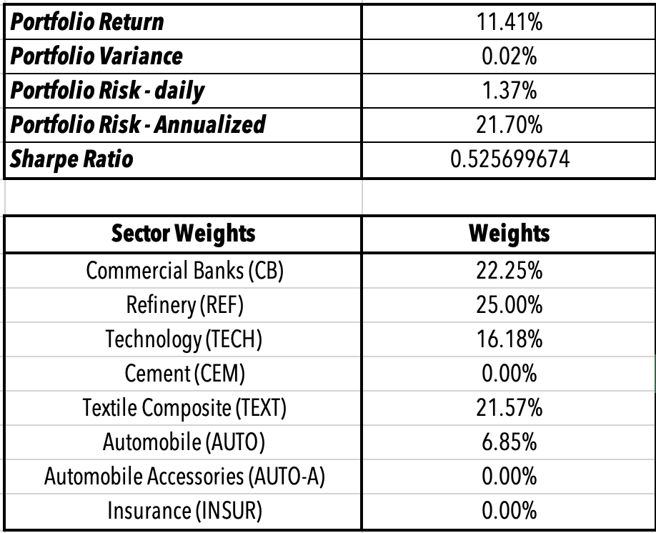

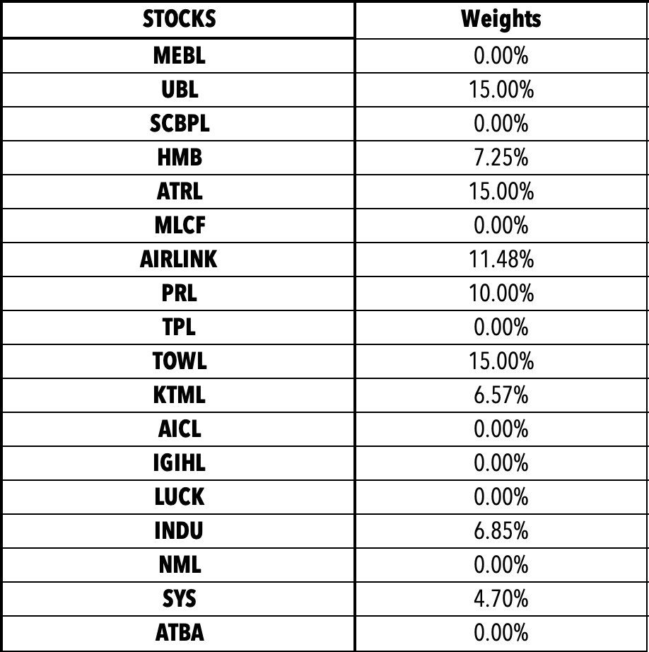

**Benchmark:** The Benchmark I have chosen for this portfolio is KSE-30 as it explains the 97% variation in KSE-100 and helps us reduce the noise present in KSE-100.